Document Reference: |  | $\APAC\Australia\2023\HENKEL AG & Co. KGaA\Henkel Statement of Work_V1.7
Version: |  | 1.7
Last updated by: |  | Nishi Kozhikkalathil
Date: |  | 17 May 2024
Status: |  | In Review

HENKEL AG & Co. KGaA
Statement of Work
SampleManager Implementation

Revision History
Version | Date | Author | Notes
0.1 | 07-Sep-23 | Nishi Kozhikkalathil / Shravan Tiwari | Created initial draft
0.2 | 19-Oct-23 | Nishi Kozhikkalathil / Shravan Tiwari | Updated as per review comments
0.3 | 3-Nov-23 | Nishi Kozhikkalathil / Shravan Tiwari | Updated as per review comments on 2nd Nov  Removed Phase1 from Pilot phase scope  Removed MSA from Pilot phase scope  Reduced no of instrument for integration from 25 -15  Reduce effort for Type A instrument from 1 to 0.5
0.4 | 4-Dec-23 | Nishi Kozhikkalathil / Shravan Tiwari | Added milestone stage-gates under section 6.1
1.3 | 18-Dec-23 | Nishi Kozhikkalathil / Shravan Tiwari | Updated Phases for Pilot A go live and Pilot B as enhancement releases.
1.4 | 15-Mar-24 | Ronghua Qiu/Nishi Kozhikkalathil / Shravan Tiwari | Updated as per the review comment ppt from Henkel.
1.5 | 27-Mar-24 | Ronghua Qiu/Nishi Kozhikkalathil / Shravan Tiwari | Updated Terms section for exit clause.
1.6 | 10-May-24 | Nishi Kozhikkalathil / Shravan Tiwari | Updated Organization name of MLA and removed hyperlink
1.7 | 17-May-24 | Nishi Kozhikkalathil / Shravan Tiwari | Updated milestone expected amount and other minor comments.

Table of Contents
1 Summary 6
1.1 Definitions 6
1.2 References 7
1.2.1 Service Provider References 7
1.2.2 Henkel References 7
2 Background 8
2.1 Project background 8
2.2 Expected Outcomes 8
3 Services to be provided 9
3.1 Scope of Services 9
3.1.1 Time and Materials Services 9
3.1.2 Training 10
3.1.3 Optional Services – Pilot Phase (not included in the SoW) 11
3.1.4 Out of Scope 12
3.1.5 Environments 12
3.2 Location of Services 15
3.3 Deliverables 15
3.3.1 Training 15
3.4 Project Closure 15
3.5 Project Implementation 15
3.5.1 Project Approach 15
3.5.2 Project Organization 16
3.5.3 Project Execution Methodology 18
3.5.4 Project Phases 20
3.5.5 Project Initiation 23
3.6 Schedule 24
3.7 Static Data 25
3.8 System Integration 25
3.9 User Acceptance Testing 27
3.10 Go-live – Pilot Phase A 27
3.11 Project Controls 27
3.11.1 Issue Management 27
3.11.2 Actions 27
3.11.3 Decisions 27
3.11.4 Lessons 28
3.12 Acceptance Criteria 28
3.13 Completion Acceptance Procedure 28
3.14 Change Control 28
3.15 Dependencies, Assumptions & Constraints 29
3.16 Roles and Responsibilities 30
3.16.1 Service Provider Responsibilities 30
3.16.2 Customer Responsibilities 31
3.16.3 Project and Business as Usual Roles 33
4 Communication Plan 34
4.1 Communication & Reporting 34
4.2 Escalation Procedure 35
5 Term 36
6 Charges 37
6.1 Consultancy Fees 37
6.2 Travel 39
6.3 Expenses 40
7 Acceptance 41
Appendix A – Delivery Acceptance Form Template 42
Appendix B – Change Request Template 45
Appendix C – Global Rollout – Phase1 Optional Items 48

Summary
This Statement of Work is made on 17 May 2024 between:
Thermo Fisher Scientific GmbH, a proprietary limited Im Steingrund 4-6, 63303 Dreieich, Germany (“Service Provider”); and
HENKEL AG & Co. KGaA, a business and having its registered address at Henkelstraße 67, 40589 Düsseldorf, Germany
This Statement of Work is issued pursuant to, and incorporates and is governed by, the Master License Agreement (“MLA”) between Thermo LabSystems Inc. and the Customer dated TBD and sets forth the specific terms and conditions relating to the provision of Services referred to in this Statement of Work. The combination of the terms of the MLA and the provisions of this Statement of Work shall together constitute the agreement between the Parties in respect of the Services (the “Agreement”). Terms used but not otherwise defined herein shall have the definitions given to them in the MLA.
In the event of any discrepancy between the provisions of the MLA and the Statement of Work, the provisions of the MLA shall apply.
The terms and provisions of this Statement of Work constitutes the agreement between the Parties in respect of the Services (the “Agreement”).
NOW THEREFORE IT IS HEREBY AGREED as follows:
Service Provider agrees to provide the Services as set out in this Statement of Work.

Definitions
The following terms have the meanings shown through this SOW:
Term/  Abbreviation | Meaning | Description
SOW | Statement of Work | This document; a formal document that provides a detailed description of the services or tasks a supplier is required to perform under contract.
PMP | Project Management Plan | A document agreed during the project initiation that, in combination with the Statement of Work, defines and verifies alignment on the project scope, resources, stakeholders and processes that will be used to manage the engagement.
QMS | Quality Management System | Thermo Fisher Informatics ISO 9001:2015 quality management system.
DEV | Development Environment | The system development environment/database.
TEST | Test Environment | The system test environment/database.
PROD | Production Environment | The production or live environment and database.
SOP | Standard Operating Procedures | Written procedures [maintained as a controlled document] prescribing and describing the steps to be taken in normal and defined conditions which are necessary to assure control of development and processes.
FRS | Functional Requirements Specification | Documents the functional and design specifications for any requirements found to require configuration, extension or customization.
RTM | Requirement Traceability Matrix | This document ensure that all the requirements specified for a project are met. The RTM document maps each requirement to the corresponding design, development, testing, and implementation phases of the project.
QCLAD | Quality Control Lab Digitalization
SFS | Smart Factory System
PMO | Project Management Office | Thermo Fisher Organization to ensure that project processes and quality are met our global standard.
Pi | Program Increment | Program increment (PI) planning is an event that creates a shared vision among Agile teams.

References

Service Provider References
The following references to Service Provider sources are made in this document.
Ref. No. | Reference | Description
1 | URS of QCLaD_2023vs2021 Review.xlsx | URS items and response by Thermo Fisher

Henkel References
The following references to HENKEL sources are made in this document.
Ref. No. | Reference | Description
1 | User Requirements Specification of QCLaD -V2 20230727.docx | User requirement document.

Background

Project background
Henkel (HENKEL AG & Co. KGaA) is looking for a laboratory information management solution that will allow laboratory information to be fully created and processed with minimal use of paper. This should provide operational benefits without any sacrifices to regulatory compliance. It is expected that the use of a properly implemented system will ensure the highest levels of overall compliance. This document provides a proposal to enable and optimize laboratory information management for Henkel.

Our proposed project plan. Includes a Pilot Phase implementing SampleManager at one site, collecting all the requirements as per the URS response document, and configuring the system to be accessible to all labs across the region and globally when they receive the system. Any enhancement request raised after pilot phase will be considered as additional requirements and will be done under a separated SOW or Change Request.

Expected Outcomes
Henkel will start with a 100% deployment of QCLaD in Dragon plant, China and further released to all Henkel adhesive sites. Connectivity and capability features must be implemented at a global scope for pilot and new enhancements done in later phases should be integrated to all rolled out sites.
Implementation of SampleManager LIMS will streamline Sample Management, Reports, Dashboards, Instrument and Equipment management, Instrument interfacing and External application integration together with the associated data acquisition across Henkel’s labs.

Services to be provided

Scope of Services

Time and Materials Services
The scope of Pilot Phase (Dragon) services is the provision of 475 days of consultancy on a time and materials basis. These days will be utilized for the activities outlined in the list below, however this is not a definitive or fixed list and can be adjusted to meet the needs of the project, as agreed and communicated by the Project Managers in written (email or meeting minutes), providing that the number of days in scope is not exceeded. Any increase in days is subject to the Change Control procedure defined in section 3.14.
The scope of the delivery is assuming that Henkel will be involved in the implementation and will share some of the delivery tasks to be enabled for future management and expansion of the system.
We will have a clear understanding of the tasks required for this project only after the requirement gathering workshop. Therefore, following the completion of this workshop, we will review and, if necessary, update the SOW. This review may encompass responsibilities, assumptions, or redistribution of estimates capped at defined budget in this SOW to ensure they align with the project's finalized requirements. In case additional budget is needed, this needs to be agreed in a new SOW or addendum hereto or a Change Request
The anticipated activities to be undertaken are defined as follows:
Pilot Phase Scope
Tasks | Effort Pilot Phase A | Effort Pilot Phase B – Hybrid Model
Kick-off & General Project Effort | 6 | 0
Requirements Gathering Workshops and Architecture analysis | 16 | -
Instrument Survey | 8 | -
Basic configuration for Stock, Scheduler, Instrument calibration setup, Folder, and Roles and Groups etc. | 32 | -
Implementation and Technical Management  Pilot Phase A:  - Sample Storage and Retention  - Equipment Management  - Inspection Plan Configuration  - Chain of Custody  - Barcode Handling  - Stocks  - Instrument Calibration and Maintenance  - Sample Management  - Sample Tracking and Audit  - Laboratory Management  - Security And User Access Management  Pilot Phase B:  - Notification and alert  - Training module configuration | 31 | 10
14 Workflow Management for Pilot Phase  Pilot Phase A: 4 workflows  Pilot Phase B: 10 workflows | 7 | 23
Sampling Scheduler  Pilot Phase A: Shift management  Pilot Phase B: Scheduler | 6 | 6
10 Lab Execution System (LES) for Pilot Phase | - | 30
6 Reports for Pilot Phase | 18 | -
8 Labels for Pilot Phase | 10 | -
1 Dashboard for Pilot Phase | 3 | -
Static Data Assistance  Pilot Phase A - 90% static data assistance coverage  Pilot Phase B - 10 % remaining static data | 10 | 5
Instrument Integration x15 – develop the parser to transfer the result data. Assist to establish the connection between instrument and SampleManager and end to end testing.  Pilot Phase A - 3 Type A and 5 Type B  Pilot Phase B - 2 Type A and 10 Type B | 17 | 31
Third party application interface  Pilot Phase A: SAP  Pilot Phase B: 1X Smartfactory (Vegam), 1-Skillmatrix (OSDP) | 28 | 39
Documentation:  Pilot Phase A: RTM, Functional Specification, Configuration Summary, User Manual for SampleManager, and Instrument connection repository  Pilot Phase B: Document updates as per phase B activities | 10 | 6
Parsing external file data (only for one format) | - | 5
System Integration Testing | 8 | 12
Installation and deployment on Dev, Test and Prod servers | 2 | 2
UAT and Go Live Support | 10 | -
Project Management | 34 | 28
SampleManager Training as per section 3.1.2.1 | 22 | -
Total | 278 | 197
Total Days (Pilot Phase) | 475

Training

SampleManager Training (Dragon Pilot Phase)
The provision of remote training, following the Service Provider’s standard courses, on the product modules listed below are delivered via the web as remote training sessions.
All Service Provider training is documented in English. Each training course will be run once, Language options and course times are described on the website entries for each course. In this proposal, we have exclusively incorporated SampleManager training in English. Chinese and German language training is detailed in the Optional Services section.
In order to help with a trouble-free experience, candidates will be invited to an introductory session. This will last long enough to explain the format, check connections and procedures and to introduce your trainer for the sessions. There will be the opportunity to ask questions.
Stream | Product/Module | Duration Days | Number of Delegates | Attendees
SampleManager | Data Configuration in SampleManager | 5 | 10 | Project Team, LIMS Administrator(s), Key / Super Users
SampleManager | SampleManager Report and Label Designer | 3 |  | LIMS Administrator(s), Key / Super Users
SampleManager | SampleManager Workflows | 2 |  | LIMS Administrator(s), Key / Super Users
SampleManager | LIMS Administration for SampleManager | 4 |  | LIMS Administrator(s), Key / Super Users
SampleManager | SampleManager LES | 3 |  | LIMS Administrator(s), Key / Super Users
SampleManager | Instrument Integration Training | 3 |  | LIMS Administrator(s), Key / Super Users
SampleManager | Forms Training | 2 |  | LIMS Administrator(s), Key / Super Users
Total Days |  | 22

Optional Services – Pilot Phase (not included in the SoW)

Implementation Services:
SN | Service Description | Consultancy Days
1 | Instrument Integration for Dragon site - 50 Type A instruments | 50
2 | Instrument Integration for Dragon site – 30 Type B instruments | 90
3 | 10 LES Methods - for Dragon | 30
4 | 5 Custom Reports - for Dragon | 15
5 | 8 Custom Dashboards - for Dragon | 24
6 | Penetration testing support for Pilot Phase | 15
7 | Code scanning to review coding standard and quality for Configuration/Custom code for Pilot Phase | 5
8 | Assistance in UAT script creation for Pilot Phase | 10
9 | Global Project Manager additional effort  Bi-weekly Project overview and tasks alignment with the project leads.  Global resource planning and management for the global activities.  Monthly PSC meeting and preparation | 11
Total |  | 250

Training Services:
Stream | Product/Module | Duration Days | Number of Delegates
SampleManager | Stability Training | 3 | 10
SampleManager | All SampleManager module training in German | 22
SampleManager | All SampleManager module training in Mandarin | 22
Total Days |  | 47

Out of Scope
The following areas are out of scope for the activities covered by this project:
- Installation of Database including development/ production system.
- Hardware (Server, Clients, Network, etc.) procurement and deployment, in this case Henkel private cloud environment preparation.
- Installation of Operating System on Server and Clients.
- Supply of cables for serial instrument connections.
- Hardware maintenance/installation/network connection and support for label printer and scanner are out of in the project scope, these should be in the responsibilities of hardware suppliers or customer IT.
- HENKEL will have their own team to manage the project and hence Henkel’s project management and Henkel’s business change management are out of scope.
- Data is assumed to be cleaned before migration and hence data cleansing is out of scope.
- Process and procedure documentation is out of scope for Thermo Fisher.
- Level 1 and 2 support will be the responsibility of Henkel. For Thermo Fisher supported item, refer to section 7 in MLA. Level 1 and Level 2 support refer to the initial point of contact and escalation within the organisation. Henkel's internal support team is usually trained to handle simple and technical inquiries from end users, such as basic usage questions, login issues, user roles setup, password setup, diagnose issues and gather more details before pushing them to Thermo Fisher support team.
- Management of the Henkel Data Centre [or Henkel third party provider] for hosting the LIMS platform if not hosted by Service Provider – assume all Henkel Technology Services will manage all Henkel Data Centre requests.
- Network and Infrastructure setup.
- Instrument Vendors engagement- Instrument Vendors engagement for any issues with the vendor's application, should be managed with the instrument vendor and Henkel. Thermo Fisher team will provide guidance on the technicality of instrument connectivity and interfacing if needed.
- Integration of instruments other than mentioned in the scope of this project, Henkel team will be able to integrate once they complete the Instrument Integration / Sweeper training.
- Good Manufacturing Practice (GMP) is not the scope of the project.
- Items not specified in the URS document will be deemed outside the scope of this project.

Environments
Henkel will supply the hosted environment for the development, testing, and production instances. All configurations/implementations and software packages as defined in this document will be installed into those environments.

SampleManager Supported Specification
SampleManager 21.1
Browser for Web Client | Microsoft Edge Chromium*  Google Chrome**
Webserver for Web Client | Microsoft® Windows® 2019 Server  Microsoft® Windows® 2022 Server
Desktop Client | Microsoft® Windows® 11 x64 Professional  Microsoft® Windows® 11 x64 Enterprise  Microsoft® Windows® 10 x64 Professional  Microsoft® Windows® 10 x64 Enterprise  Citrix Virtual Apps and Desktops™ 7 1912 LTSR CU2  Citrix XenApp® 7.15
Application Server | Microsoft Windows Server 2019  Microsoft® Windows® 2022 Server
Database Server | Oracle 19c^^  Microsoft SQL Server 2019  PostgreSQL 13#
.Net Framework | Microsoft .NET Framework 4.8 or later
Virtualization | Microsoft Hyper-V 2019  Microsoft Hyper-V® 2022
Cloud Support | Amazon Web Services  Using Amazon Aurora: PostgreSQL or Amazon RDS and hosting the SampleManager application server and SampleManager Web Server as virtual machines
Browser for Portal | Microsoft Edge Chromium*  Google Chrome**
Mobile App | SampleManager Mobile 3.1 SP1
Microsoft Office | Microsoft Office 365 in installed application mode  Microsoft Office 2019  Microsoft Office 2016  Microsoft Office 2013

Server Specification Recommendation
SampleManager can be implemented in a system architecture which minimizes downtime by providing fault tolerance and scalability. The best constellation can be defined after precise specification.
Note: Any combination of the above server and client operating systems can be used. If the database is installed on the same machine as the SampleManager server, you must use a version of the database that is compatible with the server operating system.
Henkel could consider the recommended specifications as minimum hardware and could expand for large scales of data in years.
Hardware | Specifications | Quantity
Application and Database Server | 8 or above * Intel Xeon Processor E7-4809 v3 10C 2.0GHz 20MB 115W 6.4 GT/s QPI; 32GB RDIMM memory; 2*60GB 4TB 7.2K RPM NLSAS 3.5-inch hard drive; motherboard integrated four Gigabit Ethernet ports;  Microsoft Windows Server 2016 64-bit | 1
PC for User Access (Client PC) | CPU, 2.5GHz, 4GB memory, 1GB or above hard drive, 1400x1050 / 1440x900 and above display resolution, Microsoft® DirectX®, motherboard integrated Gigabit Ethernet ports | To be identified in project
Scanner | Barcode and QR code supported  Recommend: Zebra DS2208/LS2208 | To be identified in project
Label Printer | Barcode and QR code supported, direct thermal labels  Recommend: Zebra GK888t or other brands with the same specifications, label paper roll is required | To be identified in project

Location of Services
The services will be provided remotely, at the Customer premises and at the Service Provider’s premises.
The Service Provider will always provide the best resource available to undertake the services defined in this SOW. As the Service Provider operates a global pool of resources and the priority is to match skills and experience to the role required, the best match may not be a resource located locally to the Customer location. However, the Service Provider will endeavour to employ resources local to the Customer location whenever possible.

Deliverables
The Service Provider may engage one or more of its approved partners to produce any of the deliverables defined in this SOW. The Service Provider shall in all cases remain primarily responsible to produce the deliverable and ensuring that Service Provider's obligations under this SOW are met.
This SOW exclusively covers Pilot Phase (Phase A and B) of the project. It encompasses the delivery of 475 consultancy days for Pilot Phase.
For subsequent phases (not in scope of this SoW), another dedicated SOW will be created. Based on preliminary estimations, the Service Provider is expected to provide 246 days consultancy for Phase1, 122 days consultancy for Phase 2, and 122 days for Phase 3.

Training
Under this Statement of Work, the Service Provider shall deliver 22 consultancy days as defined in Section 3.1.2.

Project Closure
The Service Provider will assist the Customer with project closure activities as defined in the Scope section above.

Project Implementation

Project Approach
The approach is based upon industry best practice and is built upon extensive Thermo Fisher experience in implementing SampleManager. The approach can be aligned with Henkel procedure for a consolidated set of key governance processes, artefacts and metrics.
A focus is placed upon the use of standard features of SampleManager; using configuration, rather than customisation, to deliver the completed system. It is acknowledged that customisation of the system may be necessary in some areas, however these will be kept to the absolute minimum while still delivering the system features that Henkel require.
Thermo Fisher Scientific recommends a partnership approach to the implementation with the customer assigning resources to work alongside the Thermo Fisher Scientific implementation team.
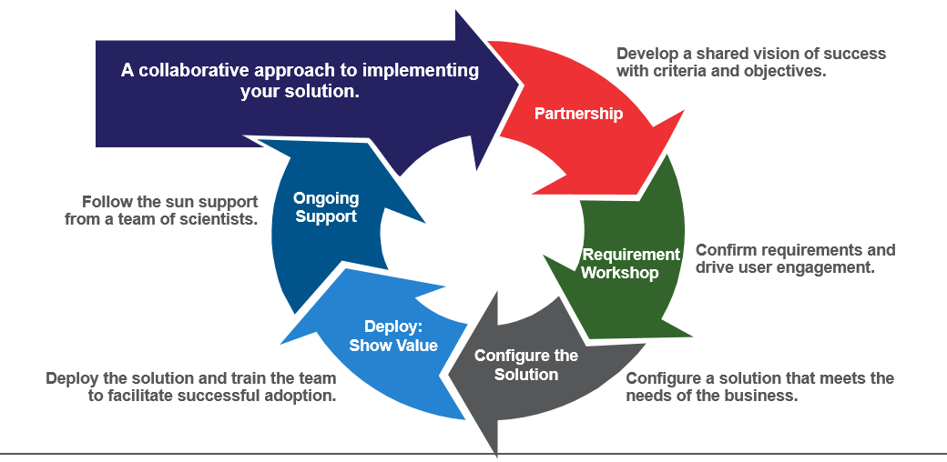
Implementation Through Partnership
The design of Henkel of implementation of a single LIMS system that allows for the sharing of licenses among multiple labs is supported but the flexibility provided via the SampleManager architecture and license model, which provide cost savings. Additionally, consolidating the system across multiple labs reduces the need for separate infrastructure setups and maintenance, resulting in further cost reduction.
By implementing a single LIMS system, it can streamline support, maintenance, and future enhancements more effectively. Our experienced team is well-equipped to handle the complexities associated with a shared system, ensuring smooth operations and efficient management.
The proposed structured approach for the implementation of the LIMS. The proposed strategy includes a single deployment of SampleManager, with one database configuration, which will enable Henkel to add new labs, instruments, integrations, and workflows in the long term. Additionally, we will provide training to Henkel personnel to support expansion across the business, enabling them to work within project teams.

Project Organization
All projects delivered to customers are led by the PMO to ensure all project are complied with our QMS and to facilitate a multi-faceted communication pathway share information on the implementation process. The Project Manager will provide written highlight reports to the customer’s project management office as detailed in Section 4.1. Each project hold teams to run workshop, train customer project team and critical users, design project prototype, configure, implement till deliver the project. As part of the overall project, we will collaborate with the Henkel Project team throughout the implementation and deployment process. The technical support team provide maintenance and support services to our all SampleManager customer after project rolls out who are fully trained and experienced problem solvers. Thermo Fisher and Henkel Project Managers will discuss and finalise the RACI matrix during the workshop.

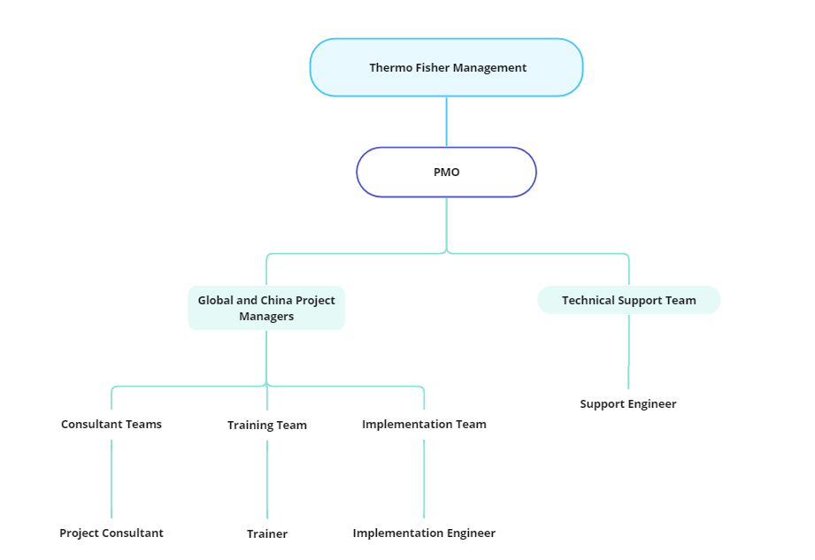
Fig: Project Organization Structure
Thermo Fisher Scientific operate as part of a global implementation service, training and support organisation. Key resources can be brought into projects from the global team to assist with project implementation and support as required.
Our Project management model encompasses the essential elements of processes, roles, structure and governance that will be implemented to ensure the successful execution of the project. It provides comprehensive overview of how we will manage, organise and govern the project. Process, which include requirement gathering, design, development & testing, change management, and risk management is explained in the various sections of this document. Our Project operating model includes a robust governance framework to provide effective oversight and control throughout the project. It defines the decision-making process escalation mechanisms and Projects controls that will be implemented to monitor and track project performance, manage risks and ensure compliance of project objectives and timeline.

Fig: RACI Matrix

Project Execution Methodology
The project will adhere to the Service Provider's established processes and approach to SampleManager implementation. The Service Provider will appoint a suitably qualified project manager and other necessary resources to oversee the delivery and execution of their responsibilities as outlined in this Statement of Work. This will be carried out in accordance with the Hybrid Project Management methodology.
Hybrid Agile refers to the Agile methodologies with Waterfall approaches. For example, in this project, it entails conducting a comprehensive requirements analysis, which is then followed by sprint execution for implementation activities.
The first requirements analysis workshop will be the level 1 process analysis and SampleManager design review; With all Henkel Stakeholders from different regions joining the workshop to review and map URS items with SampleManager out of box functionalities and identify the areas where configurations are required. This will provide holistic Pilot Phase approach and solution for the further phases. The outcome of the activities will be: 1. RTM this will be the scope of the project deliverables within SampleManager; 2. Updated project schedule; 3. Finalised Project Management Plan. The deployment and release strategy will be confirmed during the initiate and design activities.
Our implementation approach for both core and site-specific configurations involves empowering and enabling Henkel to take up ongoing and future implementations within the system. Our approach also includes an equal sharing of responsibility for configurations between Thermo Fisher and Henkel. The transition from each phase will also involve transition of responsibilities from Thermo Fisher to Henkel team.

To ensure the success of this model, we do the following:
- Identify Subject Matter Experts (SMEs) and a configuring team at the customer side during the core implementation. SME should have understanding on the entire Henkel’s lab processes and business workflows to discuss during requirement gathering sessions and take part in sprint events and testing activities.
- Key customer stakeholders will attend standard and on-the-config trainings to enable them to take up responsibilities.
- We will also aid the customer stakeholders responsible for the job during the right sections to ensure successful completion.
This approach will help to ensure fast turnaround on delivery and accurate effort estimates for implementation.
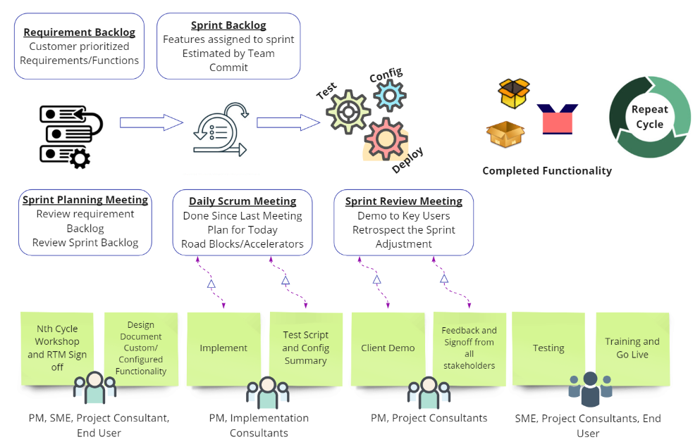
Each sprint begins with a Sprint Planning Meeting. The Sprint Planning is typically broken into two parts. Part one of the sprint meeting is a review of the product backlog items commencing with the highest priority required to forecast and deliver. Customer requirements are reviewed and confirmed for inclusion in the sprint with consideration to workload. During part two of the sprint meeting, the team decides how the work will be built. In this meeting the team will begin decomposing the product backlog items into work tasks and estimating these in hours. The output of the second meeting will be the Sprint Backlog. Daily stand-up meetings will then occur for the active sprint members.
At the end of each sprint a Sprint Review meeting is held. During this meeting the teams present which Product Backlog items they completed during the sprint. This will take place in the form of a demonstration of the new features.

After the Sprint Review meeting there is the opportunity for the Sprint Retrospective assessment to evaluate the performance and velocity of the team which will enable continual improvement throughout the sprints. If team performance is unsatisfactory, it should be escalated as per the escalation procedure as per section 4.2 and corrective action will be taken. This provides the opportunity to review what went well, what didn't, and what improvements could be made in the next sprint. The Sprint Retrospective is an integral part of the “inspect and adapt” process to allow the team to improve their overall output and to focus on the overall team performance.

Project Phases
Our proposed project plan consists of two phases – Pilot Phase A and B. During each phase, we will conduct a workshop for requirement analysis and signed off the requirement document after which we will configure and deploy the requirements for the identified lab(s). Throughout the deployment process, we will strive to minimize any potential impact on other laboratories. Our goal is to consistently improve our implementation process by leveraging the knowledge gained in previous phases.
To ensure a smooth implementation process, we propose to deploy the core LIMS system with the essential functionalities mentioned in the URS response document for the selected lab in Pilot Phase A (Dragon Site) for the first Go Live within 6 months of time. Refer to section 3.1.1.
Based on the business decision from Henkel team we can consider all the rest of the requirements mentioned in the URS document and implement in Pilot Phase B (Dragon site) as multiple enhancement releases within 5 months after Pilot Phase A Go Live. Formal UAT and Go Live will not be conducted for Pilot Phase B. Following each sprint, if there are completed deliverables, unit testing will be carried out, and the handover to Henkel will take place. Henkel resources will handle functional testing. Once testing is completed, changes will be deployed to the Production environment. It's important to note that regression testing is not within the scope of Thermo Fisher; Henkel will be responsible for performing regression testing.

Fig: Project Phases

Pilot Phase A – Dragon site
This phase consists of the implementation of the core functionality of Dragon. Identification of the core functionalities will be part of the Pilot Phase requirement analysis workshops.
This initial phase will enable us to take a more focused approach and align the project tasks and work packages with customer expectations.
Thermo Fisher will carry out the following activities during the planning and initiation stage of Pilot Phase A:
- Conduct a project kick-off meeting to establish the project's goals, objectives, and requirements.
- Identify and manage stakeholders, ensuring that their expectations are met throughout the project lifecycle.
- Prepare a project communication plan document to ensure effective communication among project team members and stakeholders.
- Identify potential risks and develop mitigation and contingency plans to manage them effectively.
- Define the roles and responsibilities of each project team member to ensure clarity and accountability.

Thermo Fisher will conduct requirement gathering with a five-day workshop for all the sites, during which we will prepare lab-specific and core system RTM. These workshops will enable us to collect detailed requirements for each site. This approach will enable us to efficiently capture all requirements and ensure that the solution meets the needs of Henkel. Thermo Fisher will categorize the requirements identified during the workshops for all labs separately, considering any unique considerations for each lab.

After the workshop, we will perform a gap analysis to identify the requirements already available in the standard system. Following the workshop, Thermo Fisher will conduct a planning session to outline the high-level tasks for each sprint in Pilot Phase A and identify dependencies. This planning session will provide a detailed timeline for design document, developing, testing. static data collection process, UAT and SIT etc.

The design and requirements will be mapped in such a manner that the core functionality will cover the major requirements for pilot phase. The gap analysis for subsequent phases will be done for each site if needed..

Once the design ideas are developed and approved, we will proceed with configuring/customizing the system. Our consultants will utilize their expertise to ensure that each of these items is configured to meet the specific needs of the selected lab, providing a tailored solution that is both effective and efficient.

Thermo Fisher will assign one dedicated resource to assist Henkel team for the creation of static data. After the design is complete, we will create a static data template and train the users on how to capture and enter static data into the template. Once the static data has been captured, we will validate the data to ensure its integrity and validity, and then load it into the SampleManager system. See section 3.7

After the configuration task is completed, the configuration is transferred to the UAT system. It is assumed that minimal formal testing will be carried out by Thermo Fisher as the primary effort is to support Henkel to deliver these activities. As the system will be delivered primarily via configuration it is not necessary to define heavy test scripts for these functions.

Upon successful completion of UAT, we will deploy the system into the production environment and provide hyper care support to ensure a smooth transition to the new system.

In the initial stage of each phase, we will develop the necessary static data templates for data collection. After capturing the static data, we will conduct validation to ensure its accuracy and integrity before importing it into the SampleManager system.

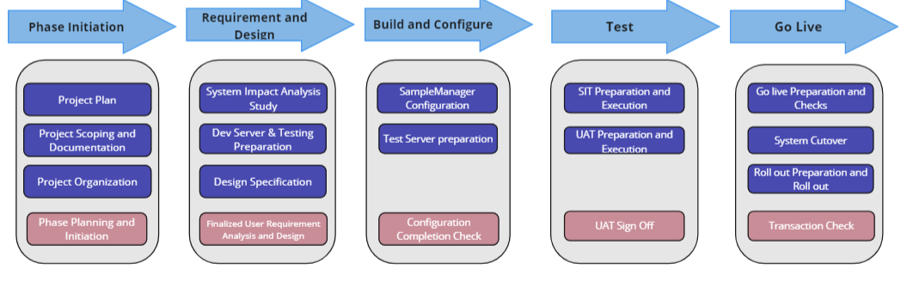
Fig: Detailed Pilot PhaseA Approach

Pilot Phase B: Dragon site with extended functionalities
In Pilot Phase B, Thermo Fisher commits to delivering the remaining requirements outlined in the RTM document. Pilot Phase B will be executed using a Hybrid Agile model. In sprint planning, Henkel’s Product Owner will identify the backlog item for the team to address. The team will proceed to design, configure/extend the functionality, and conduct unit testing. During the Sprint review session, deliverables will be demonstrated to the Product Owner. Upon approval from the Product Owner, the work will be handed over to the Henkel team. Following completion of the Henkel team’s testing, the changes will be transitioned to the Production environment. Deployment schedule and downtime on production will be discussed with Henkel team and minimize the interruption to production environment.
Global Rollout – Not in scope of this SoW
If the decision was taken by Henkel team to rollout LIMS system for other sites in different regions, Thermo Fisher team can assist as needed. The tasks to be executed by Thermo Fisher and the necessary efforts will be evaluated at that time, and any required support will be delivered via Change Request or new SoW.
The below tasks and distribution are expected to be part of global rollout, split into Phase 1 (estimated additional 5 sites) and Phase 2 & 3 (additional 106 sites). Refer to Appendix C for Global Rollout Phase 1 optional items.
Tasks | Phase 1 | Phase 2 & 3
SM/LES Client installation in Desktop/IPDAD | Henkel | Henkel
Cabinet/Folder Setup | Shared | Henkel
Master Menu Setup | Shared | Henkel
Language Translation | Shared | Henkel
Job Workflow | Shared | Henkel
Sample Workflow | Shared | Henkel
Batch Workflow | Shared | Henkel
Test Method Workflows | Shared | Henkel
Lab Methods (LES) | Shared | Henkel
Complex Report/Label Development | Shared | Henkel
Simple Report/Label Development | Shared | Henkel
Complex Dashboard Creation | Shared | Henkel
Simple Dashboard Creation | Henkel | Henkel
UAT Test case/script writing | Henkel | Henkel
UAT execution | Henkel | Henkel
SIT Test case/script writing | Shared | Henkel
SIT execution | Shared | Henkel
Static Data | Shared | Henkel
Interfaces Configuration | Shared | Henkel
End User Training | Henkel | Henkel
Documentation updates | Shared | Henkel

Project Initiation
As an initial step in preparation for the project, the project governance and organisation structure is proposed. Tasks included are shown in Table below.
Task | Description
Project Governance and organization Structure | Define the Project Board members, Roles and Responsibilities  as well as the schedule of regular Project Board Meetings.
Project Team Meetings | Schedule project team meetings, as well as attendees and  base agenda. Set expectation of outcomes.
Project Reporting  Schedule and Format | Schedule for Project Reporting, Recipients with Report Format  and Content.
Deliverable Management | Process for managing deliverables. Expected delivery format  and acceptance criteria.
Risk Management | Approach to risk management. Establish the risk register, followed by an initial risk workshop to define project risks,  qualify the risks and identify mitigation approach and owners.
Project Dependencies | What dependencies exist and how will they be managed.
Establish the RAID log | Populate risk register and update Issues, Assumptions, Decisions and Dependencies. This will be maintained as a living  document throughout project delivery.
Project Plan | Establish initial project plan through the initial workshop phase. Identify resourcing and level out. Publish the initial  plan.
Budget Management | Establish the initial project budget, agreed with stakeholders and sponsors. Publish the budget detail. Budget will be managed and tracked throughout the project and will be aligned with any subsequent change control, or business case management.
Business Case | Agree business case, and agree any action required at the start. Review business case at stages throughout project  delivery.
Lessons Log | Establish the lessons log and agree the process for capturing, reviewing, and implementing corrective actions during the  project delivery phase.
Project Initiation Meeting | Hold the project initiation meeting to formally launch the project and communicate the project overview and governance to the wider stakeholder group and project teams.

Schedule
A tentative schedule for implementation is provided below:
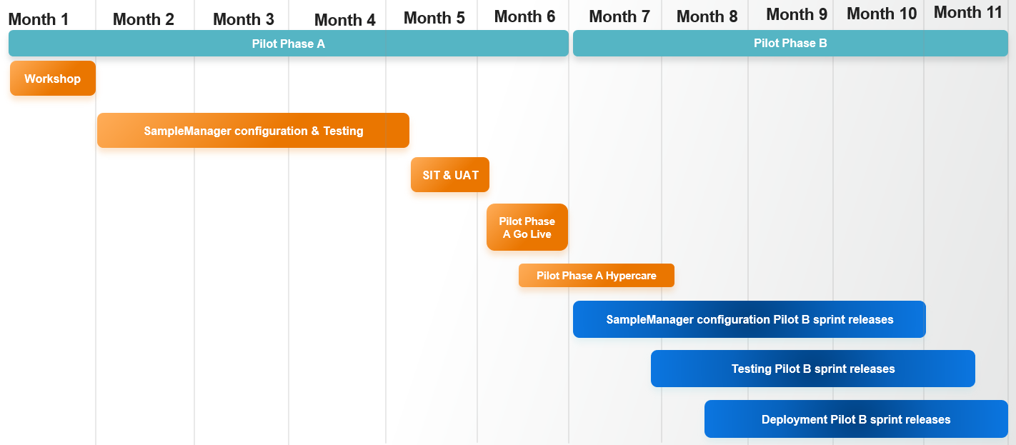
Our Project schedule assumes that hardware is in place and that the Customer’s resources are available. At this stage this is a purely indicative schedule based on the information and estimates available at this time and has not been optimised to factor in weekends, holidays etc. This indicative schedule is subject to change as the project progresses and detailed plans are developed for each stage. This schedule will be reviewed and revised as appropriate at the start and at relevant points throughout the duration of the project.
The revised schedule will always be planned to take account of weekends, public holidays and other events, to ensure that workshops and training sessions always run on consecutive working days, e.g. not starting a 3-day workshop on a Friday.
Please note that this schedule is also dependent on the relevant approvals and purchase order being in place and therefore any delay in signing this SOW or providing the purchase could result in the rescheduling of the project.
Milestones/sprints will be tracked regularly, and any scope/timeline change will be taken care of via a CR. During the project life cycle, risks and issues will be identified, and a mitigation plan and contingency plan will be developed to address them. Any delay because of technical complexity or dependencies will be communicated to the team in advance. In those cases, Henkel's and Thermo Fisher’s PM will work together to get approval from management and extend the timeline.
In the event Thermo Fisher fails to meet any deadline or milestone set forth in this Agreement, Thermo Fisher shall immediately notify Henkel in writing of any anticipated delays and the reasons therefor. Such delays shall be addressed as well through the agreed Escalation Procedure (see 4.2 Escalation).

Static Data
The static data set is a key part of any LIMS implementation. Data types such as customer, contact, price list, products, instruments, analysis, supplier, and others will be migrated by Thermo Fisher team and validated by Henkel project team. Small numbers of records can be typed in via the GUI; for larger record sets it is possible to create the data in Excel and load as CSV into SampleManager and should be aligned with the data migration activities from the previous LIMS. Henkel will collect and format the data and Thermo Fisher Scientific to assist in this process.
A limited number of static data will be manually entered by the Thermo Fisher project team for static data tables such as workflows, calculations etc. Henkel project team will observe and enter additional static data as required. Using this approach, Henkel project team gains hands on experience in configuration for being able to make their own configuration changes post system go-live and to take ownership of the system.
It is recommended to commence this activity directly after the initiation stage and is executed in parallel to the sprint activities.

System Integration
The main options to integrate third party systems (except SAP) with Thermo Fisher hosted SM environments are as below:
- Sweeper service:
  - Light weight sweeper service is uni-directional into SampleManager, and utilizes WCF on both Primary and Worker app servers.
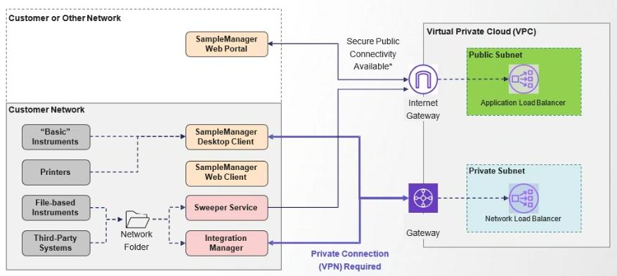
- Flat file transfer
  - This requires a third-party managed file transfer tool, to upload files to cloud server file share, where the files are then swept into SampleManager.
  - SampleManager can save files to any shared folders which is accessible for retrieval by an external system.
- REST API.
  - REST is Representational State Transfer, which is a software architectural style used for simple client-server interfaces.
  - REST APIs in SampleManager are extensible by the customer.
- Integration: SampleManager can integrate with Henkel other systems such as SAP through SM-IDI, Smartfactory(Vegam), and Skill Matrix (OSDP) through REST web service to pull and push data. SampleManager also supports to work with file transfer, API calls, direct SQL etc. The integration will be defined by both Henkel and Thermo Fisher project team.
  - SAP Integration: SampleManager can integrate with the SAP R/3 Quality Management (QM) module through SampleManager IDI (SM-IDI). SAP sends SampleManager a request that defines the characteristics that must be inspected. The details of the inspection request are defined in the worklist table that the SM-IDI will query against, download and interprets in SampleManager. Once the results are entered and approved, SM-IDI will return result values, statistical summaries of results and the usage decisions to SAP inspection request/points. Once the results or test or samples are reactivated for modification or retest, modified and new results will be returned to SAP against the previous inspection request.
  - Smartfactory (Vegam) Integration: The integration with Vegam will be done through the REST web service, and SampleManager will automatically push approved results to Vegam/Wonderware after testing is approved.
  - Skill Matrix (OSDP) Integration: Integration with Skill Matrix will be using REST API. Skill requirements are handled as training courses in SampleManager that can be assigned to the operator, analysis, instrument and preparation. If the operator has not completed the required training course or has expired training course, result entry may be blocked from the operator.

Upon completion of each stage, Thermo Fisher team will collaborate with the Henkel and third-party support team to finalize the system integration testing. Since the primary objective is to support Henkel in delivering these activities, minimal formal testing will be carried out by Thermo Fisher. Due to the fact that the system will primarily be interfaced with the external system, heavy SIT scripts aren't necessary.

User Acceptance Testing
At the end of Pilot PhaseA, the configuration is transferred to the UAT system. It is assumed that minimal formal testing will be carried out by Thermo Fisher as the primary effort is to support Henkel to deliver these activities. As the system will be delivered primarily via configuration it is not necessary to define heavy test scripts for these functions. The Henkel UAT project team will formally test the system.
Once UAT has been completed Thermo Fisher and Henkel will formally sign-off on completion of this phase of the project in preparation for the formal go-live of the system.

For Pilot Phase B, at the completion of each sprint regression testing will be conducted by Henkel to ensure that the additional functionality brought in does not impact the existing system. This can be done on a risk-based approach where the only impacted areas are in scope for the regression testing. Thermo Fisher will advise Henkel on which areas are at risk from any changes made during each sprint.

Go-live – Pilot Phase A
Thermo Fisher will work within the Henkel IT policy on deployment of applications to the production environment. This may be in the form of written implementation plans or execution of the tasks.

As part of the go-live deployment plan clear roles & responsibilities would be defined for the tasks along with rollback strategies. During the go live Thermo Fisher will support the necessary activities and provide support for issue resolution. Thermo Fisher will provide support during the hypercare period that follows Go Live to resolve any issues before formally transferring the live system to Thermo Fisher support team.

Project Controls
Service Provider will maintain the usage data of the number of days used and will report actual usage and projected usage as part of the Communication and Reporting plan as detailed in Section 4.1.
Service Provider will maintain a risk register of the risks associated with the Service Provider delivery. This will be included in the Communication and Reporting plan as detailed in Section 4.1

Issue Management
Issue Management will be the responsibility of the project manager, however, the process of recording and assessing issues (and subsequent management) will be undertaken by the Service Provider Project Manager. All issues will be captured on the project issue log, with details of the priority, owner and actions to resolve. The issues will be reviewed by the joint project team as part of the project status and review meetings.
If issues require escalation, then the escalation process defined in Section 4.2 will be invoked.

Actions
A list of all actions that are agreed during meetings, workshops, and calls, together with details of those responsible and current status will be recorded and monitored.

Decisions
Details of all of the decisions made during the project will be recorded in a decision log.

Lessons
Throughout the project, a record of what went well and what went badly will be maintained in the lessons learned section of the project log. Everyone involved in the project will be encouraged to inform the Service Provider Project Manager about any lessons learned so that they can be added to the log.

Acceptance Criteria
Deliverable Type | Acceptance Criteria | Formal Acceptance Needed? | Process for Acceptance
Technical Work | Delivery Acceptance Form | Yes | Via Adobe Sign
Documents | Document/ Delivery Acceptance Form | Yes | Via Adobe Sign
PM Reports, Informal documents | Email report template | No | Email Acknowledgement

Completion Acceptance Procedure
Acceptance of the completion of the services defined within this SOW will be confirmed by the completion and signature of the Delivery Acceptance Form by the customer representatives who are authorized to accept on behalf of the customer. Please see Appendix A for the Delivery Acceptance Form template.

Change Control
The following process will be followed if a change to this engagement is required:
- A Change Request (CR) will be the vehicle for communicating change. The CR must describe the change, the rationale for the change, and the effect the change will have on the project.
- The designated Project Manager of the requesting party (Customer or Service Provider) will review the proposed change and determine whether to submit the request to the other party.
- Both Project Managers will review the proposed change and approve it for further investigation or reject it. Service Provider and Customer will mutually agree upon charges for such investigation, which may require an additional purchase order, if any. If the investigation is authorized, the Customer Project Managers will sign the CR, which will constitute approval for the investigation charges. Service Provider will invoice Customer for any such charges. The investigation will determine the effect that the implementation of the CR will have on SOW price, schedule and other terms and conditions of the Agreement.
- Upon completion of the investigation, both parties will review the impact of the proposed change and, if mutually agreed, a Change Authorization will be executed.
- A written Change Authorization and/or CR must be approved by both parties to authorize implementation of the investigated changes – please see Appendix B for the Change Request template. Approval needs to be in the form of a mutually signed (can be via e-signature) copy of the Change Authorization/CR, which will be documented as an Amendment to this Statement of Work.
- Change Request criteria which can be revised during the initiation phase.
Criteria | Action
Additional effort required because of complex task which was not expected during initial estimation. | Align with Henkel team and discuss the additional cost, effort and timeline required for the change request.
Additional effort because of the multiple reviews and discussions.
Additional effort because of the additional requirement requested from Henkel.
Additional effort because of the task estimation not included for some tasks.
Additional timeline required because of the flaw in design or configuration. | Align with Henkel team and discuss the effort and timeline. Cost will be absorbed by Thermo Fisher.

Note: The above process applies to any change that impacts the commercial terms defined in this SOW, it may also be used for managing changes that have no commercial impact.

Dependencies, Assumptions & Constraints
Assumption/Dependency/Constraint | Description
Assumption | Maximum 10 people on a training course
Assumption | There will be 4 Requirements gathering workshops at Dragon site for Pilot Phase each of 4 days. Each will be conducted by 1 Project Manager and 1 Lead Consultant from Thermo Fisher.
Assumption | During Pilot Phase, all the requirements as per URS response document will be collected. Subsequently, starting from Phase 1 onwards, it is anticipated that only instrument integration and third-party interface requirements will be captured. Any other requirements will be considered as enhancement request and will be considered as change request.
Assumption | It is assumed that workshops will be in English with all the stakeholders from each regions participating.
Assumption | Project documentation will be in English unless otherwise stated.
Assumption | RTM will be the only document as an outcome of the workshops which will have all the detailed requirements with design ideas etc.
Assumption | UAT is mainly Henkel’s responsibility including UAT script writing and testing execution based on URS, Thermo Fisher will be responsible for resolving issues raised during UAT.
Assumption | Customer will provide appropriate resources for project activities such as workshop, configuration, interfacing and integration, and static data consolidation and load.
Assumption | Customer will provide appropriate resources IT support (database management if Henkel will choose to go on-premises deployment or Henkel managed cloud deployment, Instrument connectivity, client installation)
Assumption | In the initial discussions, the customer mentioned that they would provide integration Subject Matter Experts (SMEs). We assume that these SMEs will be available as needed throughout the project.
Assumption | Customer is responsible for overall Project Management.
Assumption | It is assumed that there will be 3 environments (Dev, Test and Prod).
Assumption | Weekly meeting will be for 1 hour with the project manager and technical lead for duration of the project.
Assumption | For agile projects daily stand up is 15 mins with project manager and technical lead.
Assumption | Custom training will take 3 days of preparation time for each day delivered. The effort would be less than assumed if Thermo Fisher and Henkel prepared the material together.
Assumption | The standard document templates - RTM, Summary format, PMP, functional specs etc. will be used from Digital Science.
Assumption | For file-based instrument the file type should be of CSV, TXT, JSON, XML, Word/Excel and PDF to interface with SampleManager.  For PDF files it should have the readable text not in the form of image.
Assumption | Thermo Fisher will provide training to enable Henkel to integrate remaining instruments independently.
Assumption | It is assumed that there will be single instance of SampleManager used by all the labs across the regions.
Assumption | It is assumed that SampleManager will be implemented in English and Chinese languages only.
Assumption | SAP, Smartfactory (Vegam), and Skill Matrix (OSDP) will be integrated in pilot phase and phase1.
Assumption | SAP P93 will be part of Pilot Phase
Assumption | Any outcomes of penetration testing will be reviewed by the joint project teams and actions will be managed via the change request process to capture even if $0 do.
Assumption | It is assumed that regression testing is not within the scope of Thermo Fisher; Henkel will be responsible for performing regression testing.
Assumption | It is assumed that SampleManager application hosted server will be able to access customer’s network.

Roles and Responsibilities

Service Provider Responsibilities
Role | Responsibilities | Resources
Management | Represent Thermo Fisher for organizational support | Xiang Wu, Shuang Liang
PMO | Responsible for managing the overall program and change within the Engagement | Nishi Kozhikkalathil
Global Project Manager | The Global Project Manager serves as the central point of contact for all project-related activities provided by the Service Provider to the Customer across all regions. Their primary responsibility is to facilitate communication and coordination between the Customer and the Service Provider on a global scale. This involves overseeing and managing the overall progress of the project and ensuring that it aligns with the Customer's global objectives. Global Project Manager also takes the lead in addressing and resolving global-level issues and risks that may impact the successful delivery of the project.  Regular Responsibilities includes  - Bi-weekly Project overview and tasks alignment with the project leads.  - Global resource planning and management for the global activities.  - Monthly PSC meeting and preparation. | Shravan Tiwari
China Project Manager/Scrum Master | Responsible for being the point of contact for the activities provided by the Service Provider for the Customer throughout China project. Assists in development and coordination of project plans, sprint events and Dev Ops activities for China site. | Zaiwang Chen
Implementation Team (China) | Responsible for leading the technical activities of the project including consultancy, training, testing, assistance with installations, issue resolution, authoring documentation and support during testing and Shadow system (go-live). | Andy Yin，
LIMS Consultants (China) | Responsible for supporting Implementation team for consultancy, authoring documentation and additional support as required. | Ronghua qiu， Lele Huang
Implementation Team (Global) | Responsible for leading the technical activities of the project including consultancy, training, testing, assistance with installations, issue resolution, authoring documentation and support during testing and Shadow system (go-live). | TBD
LIMS Consultants (Global) | Responsible for supporting Implementation team for consultancy, authoring documentation and additional support as required. | TBD
Trainer | Responsible for training and additional support as required. | Li Li Zhang
Support | Responsible to support the implementation team with technical support. | Sunny Challabathula

Customer Responsibilities
Role | Responsibilities
Sponsor | The Project Sponsor (or Steering Committee) is normally responsible for signing off the project’s budget and for ensuring the business receives the planned LIMS benefits. Key responsibilities include:  - Ensuring the project is aligned with business objectives and governed correctly  - Ensuring all senior managers know what the project is trying to deliver to the business and actively support the project in their daily actions  - Keeping the project team focused on delivering value and not getting distracted onto non-essential issues  - Providing support to the Project Manager
Project Manager | Responsible for the overall project schedule, budget, and risk management
Technical Resources | IT resource for installations etc.  IT or Business resources for report writing  IT or Business resources for instrument integration  IT resources for SAP integration  IT or Business resources for end user training  IT or Business resources to set-up the training environment for Service Provider led courses and to return the training room to the original configuration, once the training has been completed, including installation and removal of training software  IT or Business resources for other configuration as required.
Subject Matter Experts (SMEs)/Product Owner | Responsible for providing details and clarification on requirements of functionality.  The Product Owner is accountable for maximizing the value of the product resulting from the work of the scrum team, sprint review and sprint retrospective.  Responsible for defining the product vision and strategy, gathering and defining requirements, managing stakeholders, planning releases, and supporting the team.
Test Resources | Responsible for testing, authoring and reviewing of test plans and scripts, execution of test scripts.

Project and Business as Usual Roles
Role | Responsibilities
LIMS Administrators | The LIMS Administrators (LA) support and manage the application over its lifetime. The Las are the primary custodian of the investment the organisation has made in LIMS. The LAs have a central role during the implementation process and need to master key technical aspects of LIMS implementation The LAs should be knowledgeable about the Lab and IT. Key responsibilities include:  - Working closely with Thermo Fisher Consultants to help configure the LIMS and making sure a reliable, tested/verified LIMS is rolled out  - Leading user reviews, assisting with testing and the correction of any errors  - Supporting and maintaining the skills and enthusiasm of End Users and assisting in the training of End-Users  - Managing upgrades and making any required enhancements to the LIMS  - Primary interface with Service Provider Support if required  - Settings and data configuration tasks if needed  - Participating in all identified LIMS Training Courses.
Key Users | The Key Users provide the first line support for their lab area and related end-users. Key responsibilities include:  - Setting up and testing static data, co-ordinating user reviews and testing  - Keeping end-users involved and interested in the goals of the project  - Discussing implementation issues with the Project Manager and the Service Provider  - Training or assisting in the training of End-Users  - Acting as first-line support for End-Users  Participating in the identified LIMS Training Courses.
IT Infrastructure Lead | Responsible for setting up internal hardware/software infrastructure within Customer organisation. This person provides a representative system that closely resembles the final production system.
Quality Manager | This role is responsible for aligning LIMS procedures with company quality and compliance requirements. This includes updating company Quality procedures / SOP’s and related documentation and leading on any validation required.

Communication Plan

Communication & Reporting
The Service Provider Project Manager will provide written highlight reports to the Customer and Service Provider’s PMO. The content, format and frequency of these reports will be agreed during project start-up, but as a minimum will include the following:
- Progress summary
- Updates on key risks and issues
- Activity in the reporting period and planned activity for the next period
- Milestone and timeline updates
- Deliverable updates
The Service Provider and the Customer will meet at the start and end of the project, to formally start and close the project. They will also meet on a periodic basis and at the end/start of each stage throughout the project, to review progress, risks and issues and agree plans for the next stage.
Ad hoc meetings will be schedule as required to discuss issues, change requests, in line with the escalation and change control procedures defined for this project, and other matters as required.
The respective Project Managers will agree, and schedule other meetings and communication as required to facilitate communication within the project team and other stakeholders, as part of project initiation, these are likely to include but not limited to regular team meetings, planning meetings, workshops, and stakeholder meetings.
Wherever possible, meetings will be conducted online, or by other remote meeting services, to avoid travel.
All project meetings will be documented, with the notes and the associated actions and decisions distributed to the Customer project manager. Actions and decisions will also be recorded, monitored and maintained in a project log throughout the duration of the project.

Escalation Procedure
The Project Manager (Service Provider or Customer) will escalate issues and other matters according to the high-level plan agreed below. During the initiation phase, a more detailed communication plan for the weekly and monthly PSC meetings and monthly reports will be discussed and maintained. The communication plan and escalation plan will be adapted and finalised together.
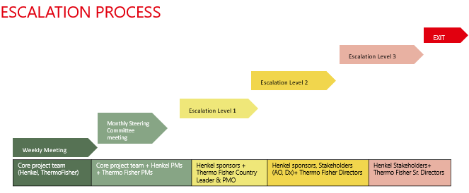

Term
The Services under this Statement of Work shall commence on an agreed date on receipt of a relevant purchase order by the Service Provider unless terminated as provided under the terms of the MLA and conclude upon completion and approval of all deliverables and milestones defined herein.
Thermo Fisher and Henkel will agree on an exit management period if any (partial) termination of services occurs. During an exit management period, the Service Provider shall provide reasonable assistance, co-operation and documentation to assist Henkel in transitioning the services to another Service Provider as a replacement or to Henkel internally always ensuring business continuity. The Service Provider shall be compensated for such exit management services incremental to the normal provision of services on a time basis defined in the rate card.

Acceptance
AGREEMENT:
By our signature, we agree to the above terms.
IN WITNESS WHEREOF, the Parties have executed this Statement of Work and each acknowledges having received one duly executed original.
The Parties signing this document are assumed to have the necessary authority to agree to the terms set out in this SOW. If the Customer will not be providing purchase orders in respect of the charges set out in this document, then signature of this is assumed to be authorisation for payment in lieu of a Purchase Order.

HENKEL AG & Co. KGaA |  | Thermo Fisher Scientific (China) Co. Ltd
(Customer Signature) |  | (Thermo Fisher Signature)
(Customer Printed Name) |  | (Thermo Fisher Printed Name)
(Customer Title) |  | (Thermo Fisher Title)
(Customer Date) |  | (Thermo Fisher Date)

Appendix A – Delivery Acceptance Form Template
The template document has been inserted as an image in this template. To use the document in context of a project the separate template will be used.
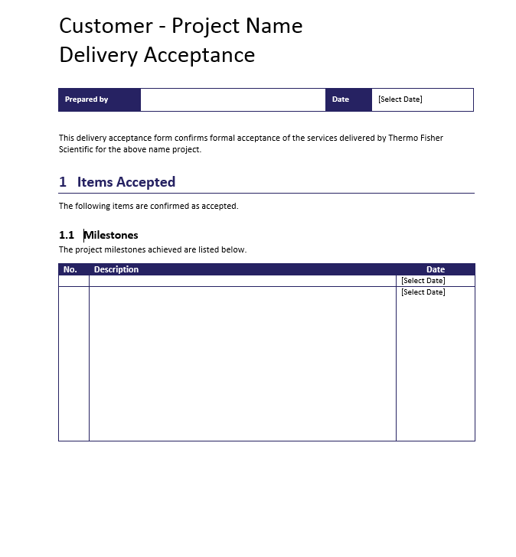
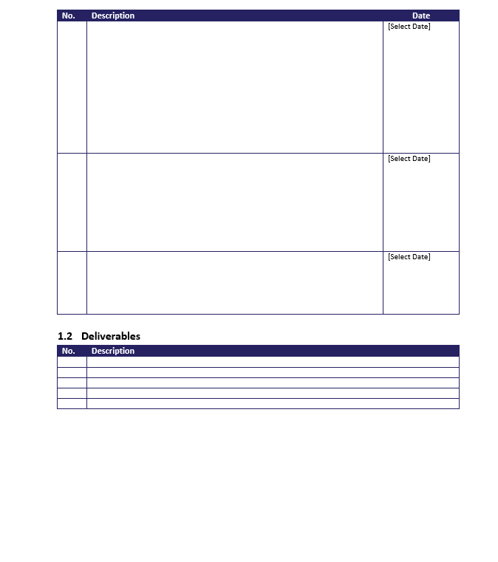
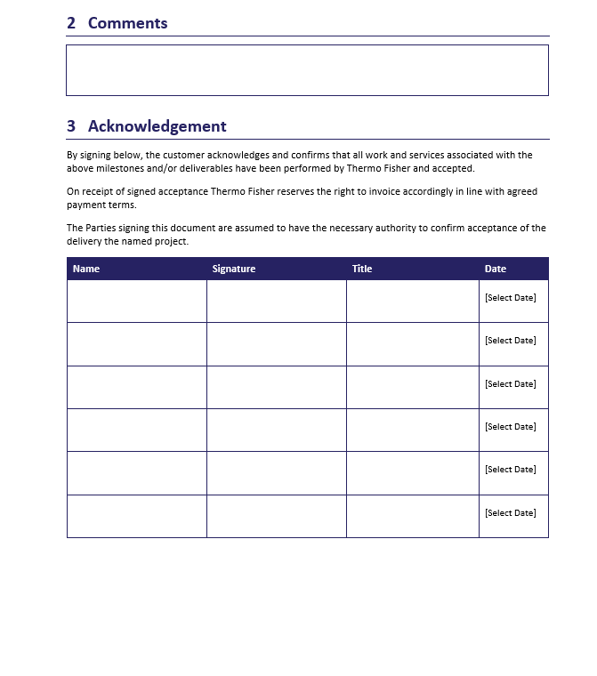

Appendix B – Change Request Template
The template document has been inserted as an image in this template. To use the document in context of a project the separate template will be used.
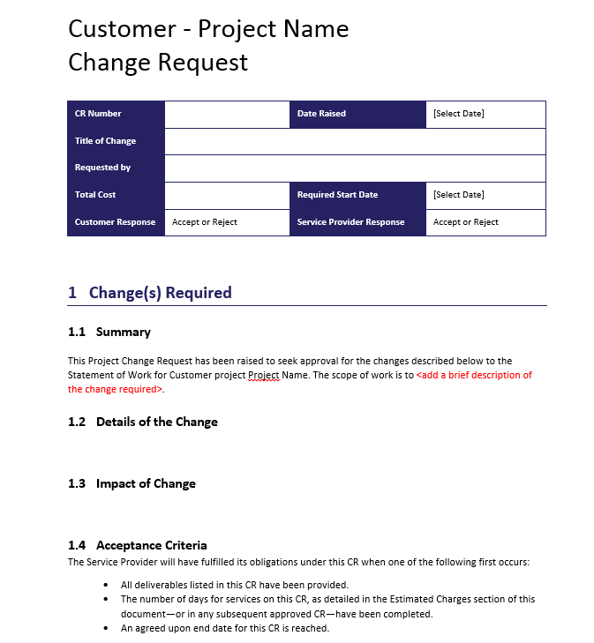
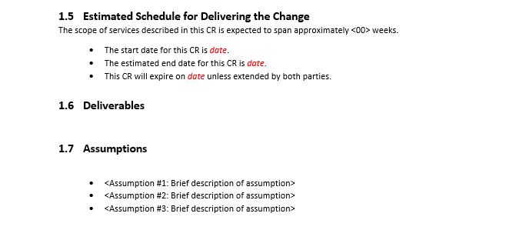
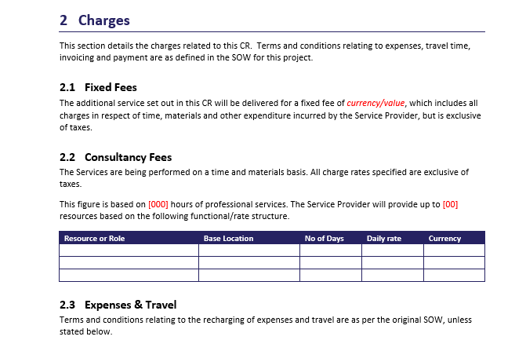
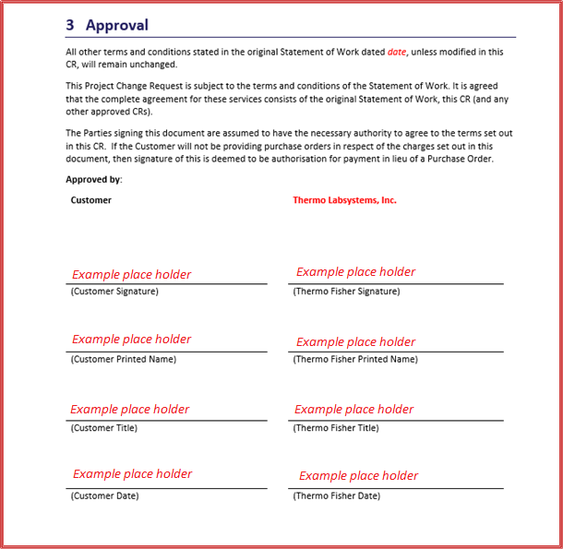

Appendix C – Global Rollout – Phase1 Optional Items
SN | Service Description | Consultancy Days
1 | Instrument Integration for Phase1 – 25 Type A instruments | 25
2 | Instrument Integration for Phase1 – 25 Type B instruments | 75
3 | 5 LES Methods - for Phase1 five sites | 15
4 | 5 Custom Reports - for Phase1 five sites | 15
5 | 5 Custom Dashboards - for Phase1 five sites | 15
6 | Code scanning to review coding standard and quality for Configuration/Custom code for Phase1 | 5
7 | Assistance in UAT script creation for Phase1 | 5
Total |  | 155

